Capital Expenditure Request
Proposed By | Niki Barber / Accounting Manager
Data Gathering | Carmen Shields / Programmer Specialist  Paul Stanek / Senior Programmer/Analyst
Approved By | Steve Williams / IT Manager
Developer | ????
Date

Requirements: Checklist
- Request details
- Quote details - Optional
- Approvals signature
- Accounting Details

Process Flow
Request Submission (Requestor)
The Requestor initiates the procurement process by completing the Procurement Request Form. The following information must be provided:
- Vendor
- Description
- Estimated Start Date
- Estimated Cost
- Request By (Full Name)
- Comments
- Requested By (Signature)
Validation Requirement
The Requested By signature is mandatory. A procurement request cannot be submitted for Department Approval until the form has been completed and the required signature has been provided.

Department Administration Approval Process
- When a request is submitted by the requestor, it is automatically forwarded to the Department Page.
- The Department Page displays the complete request details for review.
- The department approver reviews the request and clicks the Approve button.
- Upon clicking Approve, a modal window is displayed requiring the approver to provide:
  - Signature
  - Approval Date
- After the signature and date are entered, the approver clicks Approve to confirm the approval.
- The system updates the request by:
  - Saving the approver's signature and approval date in the Department Approval section of the request form.
  - Updating the request status on the Requestor Page to reflect that the request has been approved by the department.

Financial Approval
The Finance Department reviews the Procurement Request Form to verify the availability of funds and ensure compliance with financial policies. Upon successful review, the request is approved and forwarded to the next stage of the approval process.
Conditional Approval
If the Estimated Cost exceeds 25,000, the Procurement Request Form must be routed to the President for additional approval. The request cannot be finalized until the required Presidential Approval has been obtained.
Final Output
After all required approvals have been completed, the user selects the Finished button to finalize the procurement request process.
Upon completion, the system generates a printable version of the fully approved Procurement Request Form for recordkeeping and processing.
No
Signature
User
Form
Fill up details
Requested
Signature
Department
Sign???
No
Yes
Accounting
Yes
No
Presidential
Yes
No
Sign???
Over 25,000??

Application: PAUL
Home Page
Request
Department
Financial
Presidential

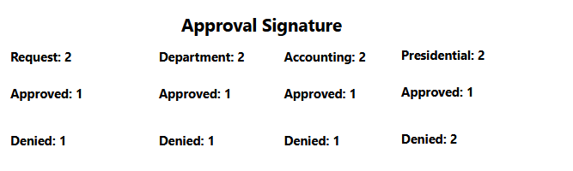

Requestor
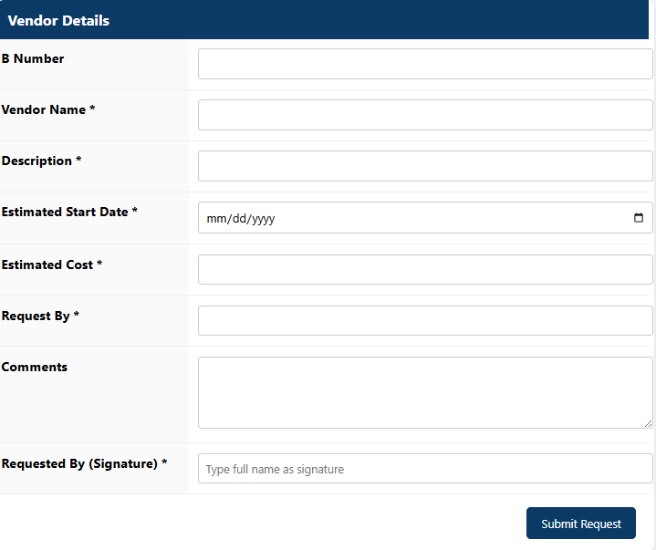
Request
Department
Financial
Presidential

Department
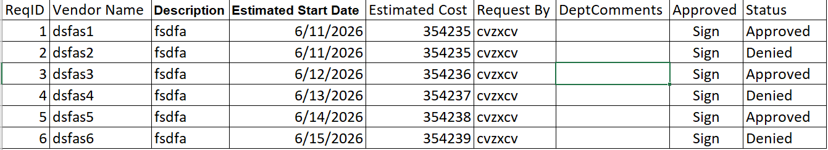
Request
Department
Financial
Presidential

Final output Report form.

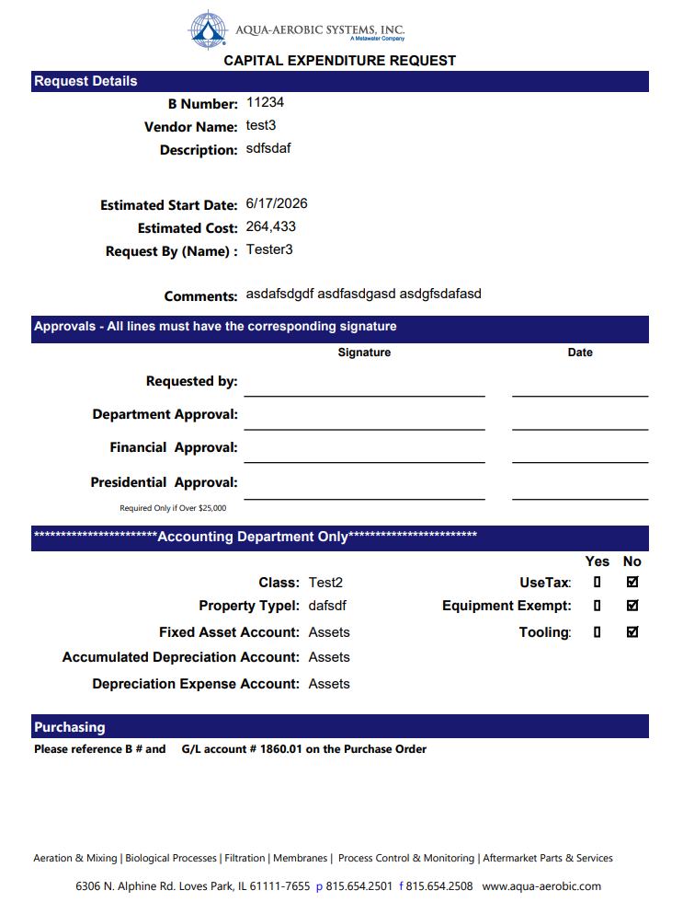

Manual Process – Request Details Workflow
- The user enters and submits the request details.
- The user waits for the Accounting Department to complete the required accounting information.
- Once all request and accounting details are completed, the user prints the request form.
- The user signs the printed form.
- The signed form is emailed to the Department for review and approval.
Note: The request form should only be printed after both the request information and accounting details have been completed to avoid reprinting and ensure accuracy.

Option 1

Report Process Flow
- Generate the request form through the SSRS report and save it as a PDF document.
- Obtain the required signature on the PDF (either handwritten or electronic signature).
- Send the signed form to the Department via email and update the request status in the report system.
- After Department approval, send the form to the Accounting Department for approval and update the status accordingly.
- Prepare the final approved document, which may be maintained as a hard copy or as an electronically signed document.
Notes:
- SSRS does not support signature functionality; therefore, all signatures must be completed either by handwritten signature or through an electronic signature solution.
- The final document approval process can be managed using electronic signature platforms such as DocuSign, which can automatically notify designated signatories via email and facilitate the signing workflow.
Accounting Home Page
Path: http://aquaerprep/Reports/report/carmenreports/CapitalExpenditure/HomePage

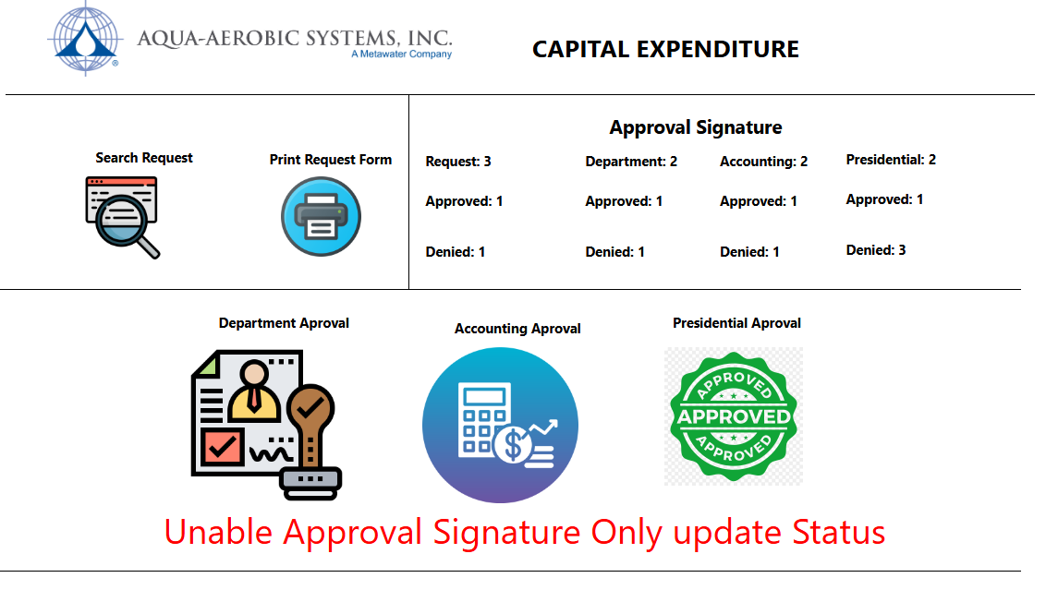

User Home Page
Path: file:///C:/study/Capital%20Expenditure%20Request/Users.html
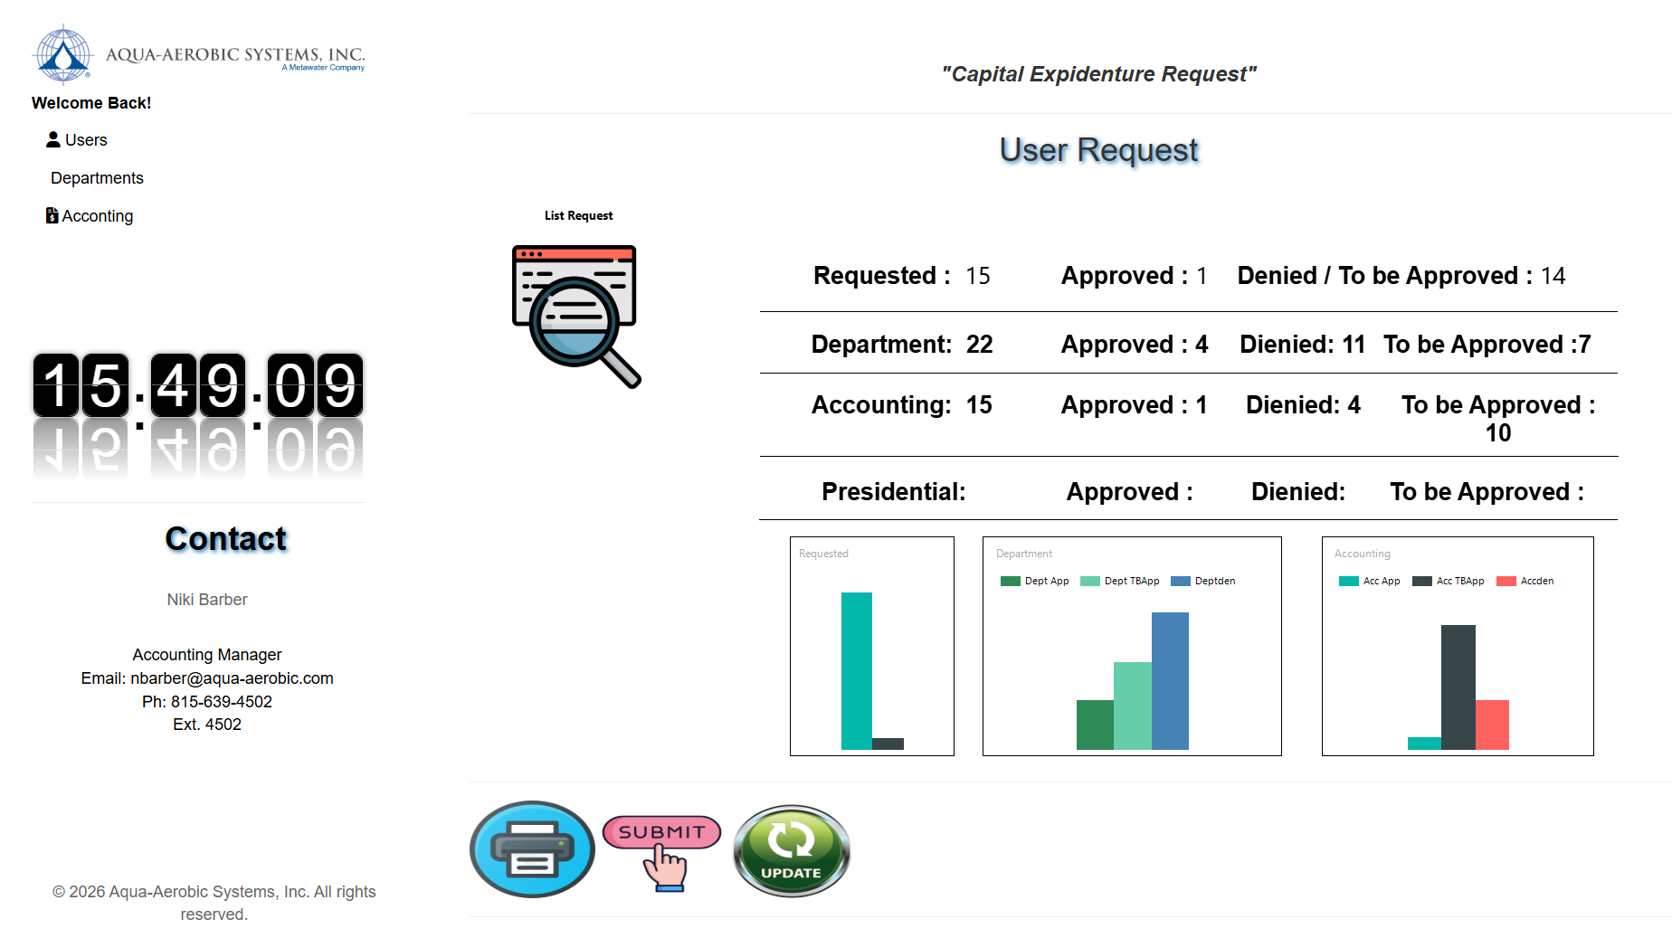

User Functions
- Submit a request.
- View the list of requests.
- Update request: If the status is to be approved by department the user can update the request but once the request has been denied or approved the user cannot update the request.

Request List Categories
Users can view requests under the following categories:
- Pending Department Approval – Requests that have not yet been approved or denied by the department.
- All New Requests – All newly submitted requests.
- Requests Requiring Accounting Details – Requests that still need accounting information to be completed.

Print Form
The Print Form feature helps reduce unnecessary form printing by allowing users to print only relevant requests:
- Requests that have not yet been processed by the department.
- New requests with complete Request and Accounting details.
Note: If any updates are made to the report form, clear your browser history/cache before accessing the report to ensure the latest version is displayed correctly.

Department Home Page
Functions:
Can update for the status of the request of Department approval.
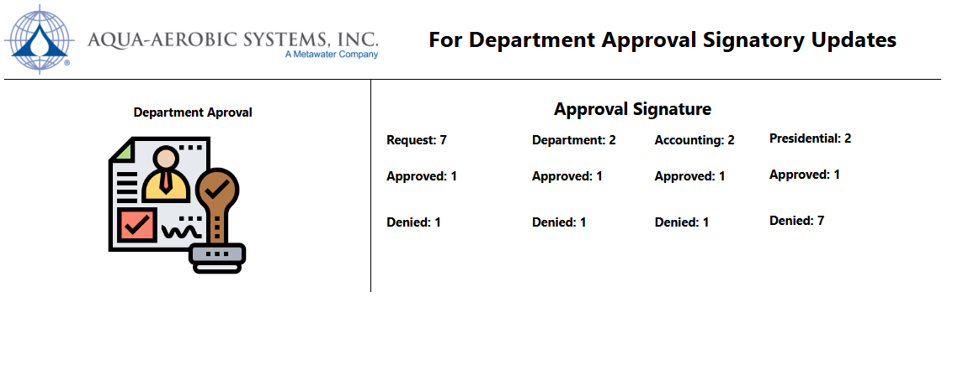
List of request approvals
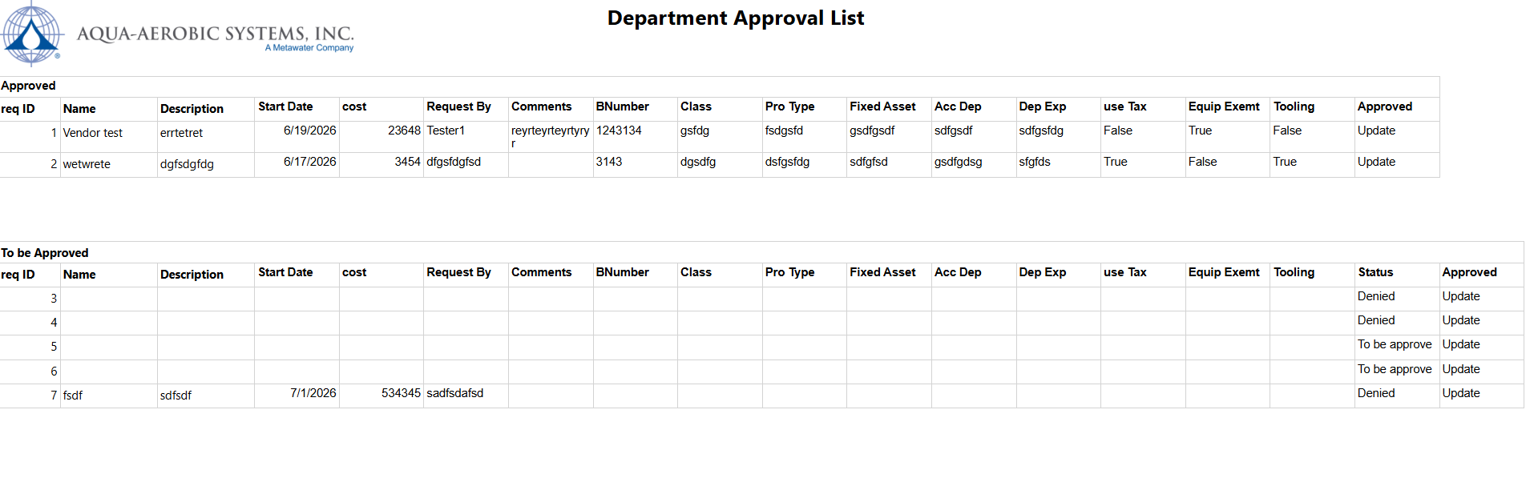

Once a request reaches Department Approved status, the Print Form function should be disabled to prevent duplicate or redundant printing.
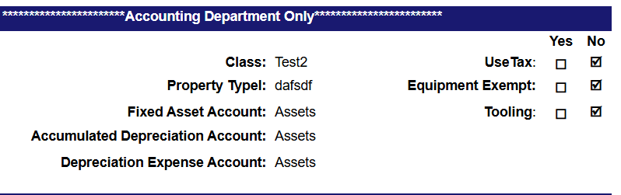
The Accounting Department should be allowed to enter the B Number and other accounting-related details before the requestor prints the form. This ensures that the printed form already contains the required accounting information, eliminating the need for manual handwriting and improving accuracy and efficiency.

Option 2
Web Form: Need help from chuck to unable save details from form.
Requirements: Storage for the details and E-signature process.
Path: file:///C:/study/Capital%20Expenditure%20Request/index.html

